Project ID – PNT2022TMID21860

Anaconda is a distribution of the Python and R programming languages for scientific computing, that aims to simplify package management and deployment. The distribution includes data-science packages suitable for Windows, Linux, and macOS. It is developed and maintained by Anaconda. which was founded by Peter Wang and Travis Oliphant in 2012 As an Anaconda, it is also known as Anaconda Distribution or Anaconda Individual Edition, while other products from the company are Anaconda Team Edition and Anaconda Enterprise Edition, both of which are not free.

WAY TO INSTALL ANACONDA

STEP 1: Download and Anaconda

STEP 2: Install the Anaconda

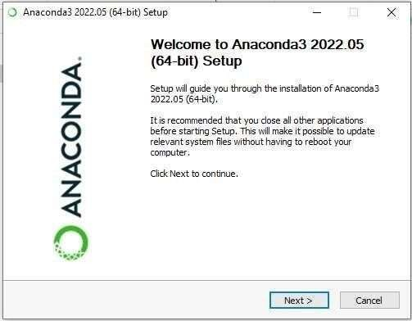

STEP 3: Click I Agree

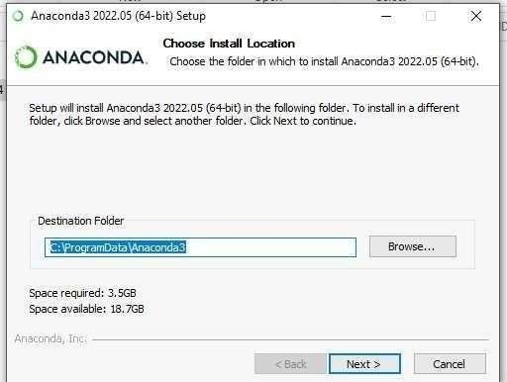STEP 4: Choose the Installation Location

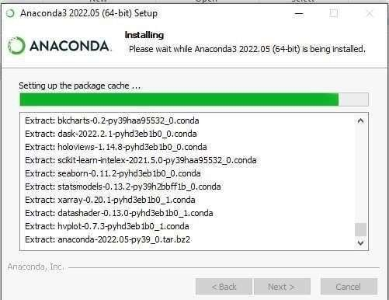STEP 5: Installing the Requiring packages

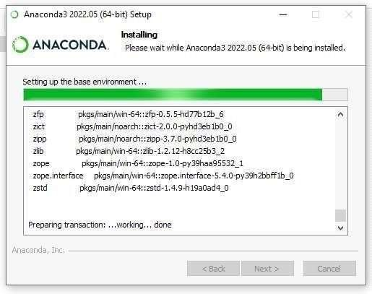STEP 6: Setting up the base environment

STEP 7: Succesfully Installed and check the Anacoda Navigator working or not

